1. **Abstract:**

Damping is the dissipation of energy from a material or system under vibration. Successful modeling and designing of a vibrating system requires proper understanding of the types of damping involved and the values of the damping coefficients. This project seeks to develop an experimental setup to successfully measure the damping coefficient in a vibrating beam. Further investigation is carried out to study the effect of mass location along a vibrating cantilever beam and its effect on damping

. 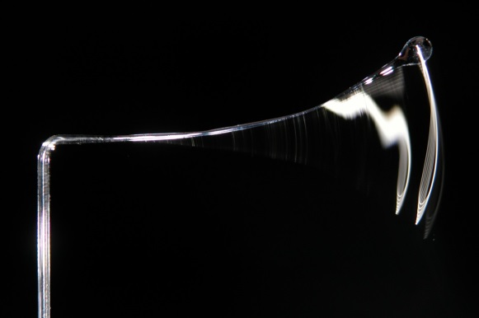

Figure Vibrating Structures

1. **Introduction:**

The dissipation of energy from a vibrating system and its importance can be seen in many applications in everyday life. A door closing due to a spring-damper mechanism or shock absorbers in automobiles is two examples where damping is important. There are three main types of damping: viscous damping, coulomb damping and solid/material/hysteretic damping. These types of damping are categorized based on the medium which is used to ‘take’ the energy away from the system. If the vibration of the system is being resisted by a fluid medium, then the damping is considered as viscous damping. If the vibrating system is in contact with another solid surface whereby energy is dissipated by dry friction, then the damping is known as Coulomb damping. Hysteric Damping is caused by the repetitive internal deformation within the atomic planes of a structure. There are two main methods of measuring damping in a system; (1) the logarithmic method which utilizes the time domain and (2) the bandwidth method which uses frequency domain. In this paper, a simple cantilever beam will be designed to vibrate in a fluid medium from which the damping ratio(ζ) and damping coefficient will be measured. An in-depth look will be taken at every step involved in the development of proper devices for signal processing and data acquisition, which will be used for graphical analysis. The damping ratio and damping coefficient will be measured using the logarithmic decrement method (Fig. 1). Damping can be divided into three cases: (a) under-damping, (b) over-damping and (c) critical damping (Fig. 2). Under-damped vibration is a system where the oscillation gradually decreases until the system returns to its equilibrium position. If the system slowly returns to equilibrium without oscillating, it is an over-damped vibration. If the system ‘quickly’ returns to equilibrium without any oscillation, it is a critically damped vibration. In this paper, the beam will be vibrating in an under-damped case.

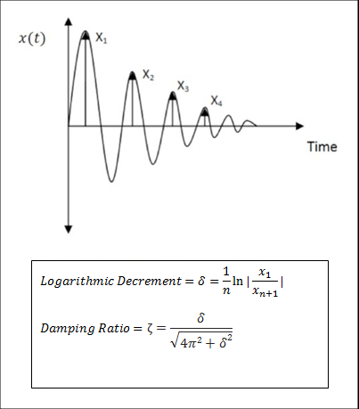

Figure Using Logarithmic Method to Find Damping Ratio.

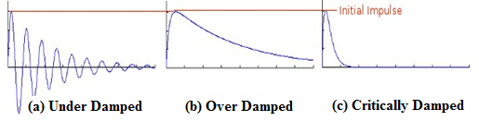

Figure Three Different Cases of Damping

To have control over the natural frequency and damping of a system can prove to be crucial. In many cases, systems fail due to excessive vibration and lack of an efficient damping system. Moreover, the alteration of the natural frequency of a structure can avoid the occurrence of resonance. When a system or structure is excited by an external force matching its own natural frequency resonance occurs. Resonance causes severe deformation of the structure and can cause the system to fail severely. For example, the Tacoma Narrows Bridge in the State of Washington collapsed 4 months after it was built. There were many factors causing the failure but the speed of winf reached a soaring 40 mi/hr. which excited the bridge with a frequency matching its natural frequency. Shown below is an image of the bridge collapsing.

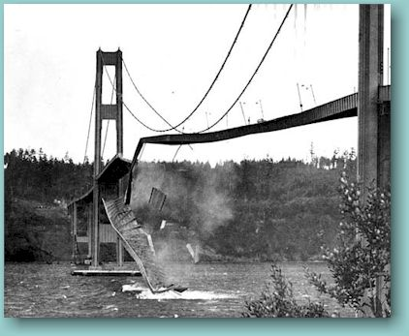

Figure Tacoma Narrows Bridge Collapsing

1. **Objective:**

For students to have a better understanding of how theoretical concepts are taught and derived, an experimental and research oriented approach is beneficial. As students progress in their curriculum, material and topics they encounter become progressively difficult to understand and comprehend. This project will give them a hands-on experience on how to find damping and natural frequencies of beams experimentally. This project will utilize several fundamental tools, including CATIA, electric circuits, and many mechanical engineering concepts students are taught throughout their collegiate career. Our main project objectives include:

1. Create an experiment/device to measure viscous damping.
2. Develop a procedure for the experiment to measure damping.
3. Study the effect of mass location on damping.
4. Find the natural frequency of a cantilever beam.
5. Compare theoretical values to measured values through experiment and CATIA analysis.
6. **Definitions and Terminology:**
7. **Cycle**: The movement of a vibrating body from its undisturbed or equilibrium position to its extreme position in one direction, then to the equilibrium position, then to its extreme position in the other direction, and back to equilibrium position is called a cycle of vibration**.** A Cycle is one full wave on the graph: [3]

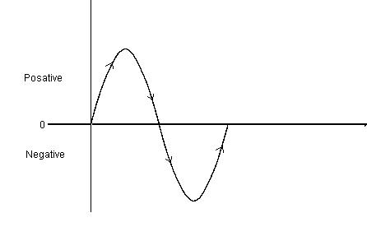

Figure Representation of one cycle

1. **Amplitude**: The maximum displacement of a vibrating body from its equilibrium position is called the amplitude of vibration [3]
2. **Period of oscillation**: The time taken to complete one cycle of motion is known as the period of oscillation or time period [3]

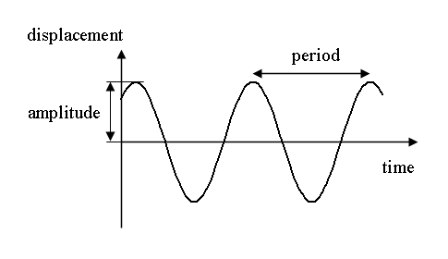

Figure Represenattion of amplitude and period

1. **Natural frequency.** If a system, after an initial disturbance, is left to vibrate on its own, the frequency with which it oscillates without external forces is known as its natural frequency.[3]
2. **Damping:** the dissipation of energy from a material or system under vibration is called Damping. Damping is modeled as one or more of the following types:
3. Viscous Damping: Viscous damping is the most commonly used damping mechanism in vibration analysis. When mechanical systems vibrate in a fluid medium such as air, gas, water, or oil, the resistance offered by the fluid to the moving body causes energy to be dissipated.
4. Coulomb or Dry-Friction Damping: It is caused by friction between rubbing surfaces that either are dry or have insufficient lubrication. The damping force is constant in magnitude but opposite in direction to that of the motion of the vibrating body.
5. 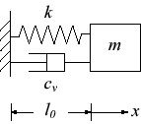Material, Solid or Hysteretic Damping. When a material is deformed, energy is absorbed and dissipated by the material. The effect is due to friction between the internal planes, which slip or slide as the deformations take place. [3]

Figure Spring Damper System

1. **Stress**: Stress is force per unit area [2]
2. **Strain:** Strain is defined as deformation of a solid due to stress [2]
3. **Yield Strength**: yield strength or yield point of a material is defined in engineering and materials science as the stress at which a material begins to deform plastically.[2]

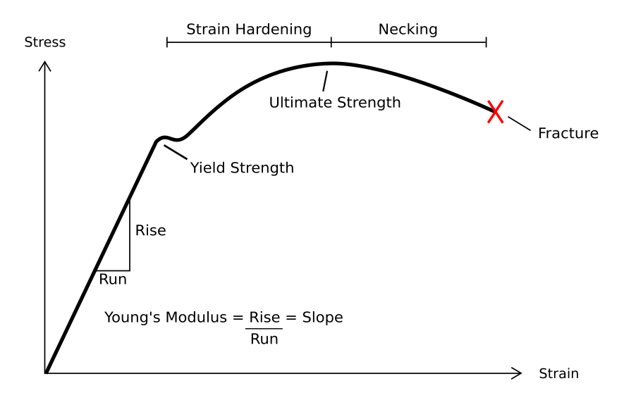

Figure Stress Strain Curve

1. **Finite Element Analysis (FEA):** Finite Element Analysis (FEA) is a type of computer program that uses the finite element method to analyze a material or object and find how applied stresses will affect the material or design. Some of these programs include CATIA, SolidWorks, Patran-Nastran, etc…
2. **Strain Gage:** A Strain gage (sometimes referred to as a Strain Gauge) is a sensor whose resistance varies with applied force. It converts force, pressure, tension, weight, etc., into a change in electrical resistance which can then be measured.[6]



Figure Strain Gage

1. **Mathematical Formulation:**
2. **To find Maximum Deflection of the Cantilever beam:**
3. The moment created by the applied load at the free end of the beam around the fixed end is:

$M_{max}=PL$ [1] ……………………………………………...…………….. (eq.1)

M: Moment around fixed end (lb.in)

F: Load applied at end of bean (lb)

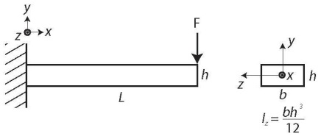L: Length from location of applied load to fixed end (in)

Figure Loading on Cantilever Beam

1. The maximum stress due to the moment created by loaf F is given by the formula:

$σ_{yp}=\frac{M_{max}c}{I}$ [1] …..……………………………………………………….. (eq.2)

$σ_{yp}$: yield strength (psi)

c: the distance between neutral axis and maximum point of stress (in)

I: moment of inertia (in4)

1. To find moment of inertia for a rectangular cross section:

$I=\frac{1}{12}bh^{3}$ [1] …..……………………………………………..……….. (eq.3)

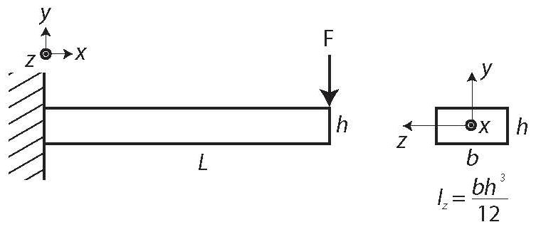

Figure Cross-Sectional Dimensions of a Rectangular Beam

1. Rearranging and substituting equations 1, 2 and 3, the max load can be found:

$P_{max}=\frac{σ_{yp}I}{Lc}$ [1] ….…….…………………………………………...…….. (eq.4)

1. When maximum load is calculated, the maximum displacement can be found using the displacement formula of a beam:

$y=\frac{Px^{2}}{6EI}\left(3l-x\right)$ $since P is applied at free end , x=l$ $∴ δ_{max}=\frac{P_{max}L^{3}}{3EI}$

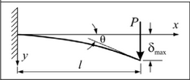

Figure Maximum Displacement Visualization

1. **To find the Natural Frequency and Damping Coefficient of a Beam Experimentally:**
2. After obtaining experimental results the logarithmic decrement can be calculated: $δ=\frac{1}{n}ln⁡(\frac{x_{1}}{x_{n+1}})$ [3]…….……..……………………………………….. (eq.5)

$δ$: logarithmic decrement.

n: number of consecutive cycles of motion.

x1: amplitude of initial impulse

x(n+1) : amplitude of decaying impulse



Figure Damping Effect

1. Damping ratio can be found utilizing the logarithmic decrement value:

$ζ=\frac{δ}{\sqrt{{(\left(2π\right)}^{2}}+δ^{2})}$ [3]….….……………………...……………………………….. (eq.6)

$ζ$: Damping Ratio

1. Time between the two consecutive amplitudes or one cycle ($τ_{d}$) is measured from the experimental data obtained. From the time obtained the damped natural frequency can be calculated using the equation that follows:

$τ_{d}=\frac{2π}{ω_{d}}$ [3]………………..…………………………………………………….. (eq.7)

$τ_{d}$:damped period of vibration

$ω_{d}$: damped natural frequency.

1. The natural frequency can then be found by rearranging the equation for the damped natural frequency:

$$ω_{d}=ω_{n}\sqrt{1-ζ^{2}}$$

$∴ ω_{n}=\frac{ω_{d}}{\sqrt{1-ζ^{2}}}$ [3]….…………………………………………………….. (eq.8)

1. **To find natural frequency Theoretically:**
2. The natural frequency of a cantilever beam is given theoretically by the following equation:

$ω_{n}={1.875}^{2}\sqrt{\frac{EI}{mL^{4}}}$ [3]….…….………………………………………….. (eq.9)

m: mass (lbs.)

1. Mass is equal to the density multiplied by the area.

$m=ρA$….………………………………………………………..……….. (eq.10)

$ρ$: Density (lbs. /in3)

A: cross sectional area (in2)

1. Substituting equation 10 into 9, the natural frequency can be found as a function of elastic modulus, moment of inertia, density, area, and length.

$ω_{n}={1.875}^{2}\sqrt{\frac{EI}{ρAL^{4}}}$ [5]….…………………………………….…..……….. (eq.11)

1. **Technical Approach:**

Figure Flow Chart

1. **Design Beam and Fixture:**

The design needs to implement a maximum displacement range where the beam cannot exceed its elastic region since the beam may exceed yield point when there is too much force applied on it.

1. Material Specification:

Length: 12inches

Width: 1inch

Thickness: 0.125inches

Material: Aluminum 6061-T6

1. Find maximum load using material specification:
$$P_{max}=\frac{σ_{yp}I}{Lc}=\frac{\left(40000\right)(0.0001627)}{\left(12\right)(0.0625)}=\frac{8.68}{1.5} =5.78lb$$

$$σ_{yp}=40000psi$$

$$I=\frac{1}{12}bh^{3}=\left(\frac{1}{12}\right)\left(1\right){(0.125)}^{3}=.0001627{ in}^{4}$$

$$L=12 in$$

$$c=\frac{1}{2}h=0.0625 in$$

2. Find maximum deflection from max load calculated:
$$δ_{max}=\frac{P_{max}L^{3}}{3EI}=\frac{\left(5.78\right){(12)}^{3}}{3\left(10*{10}^{6}\right)(0.0001627)}=2.048 in$$

$$E=10*10^{6}psi$$

3. **Strain Gage Selection:**

Strain gauge is required to acquire the amount of strain in the cantilever beam. There are many different types of strain gauges that specify in different areas of studies. The standard strain gage series selections chart[6], is used to select which strain gauge is an ideal fit for this project. The strain gage used for this experiment is CEA-13-062UW-350. The CE represents a thin, flexible gage that has the capability for direct lead wire attachment. The A represents a constantan alloy in self-temperature compensated form. The S-T-C Number is the approximate thermal expansion coefficient of the structural material on which the gage is to be used. If it doesn’t involve unreinforced plastic, the S-T-C Number usually is 13. Gage length of 0.062 in. provides the best results of strain gradient, areas of peak strain, and space for gage installation. Gage pattern of UW and gage resistance of 350 ohms are selected. The gage factor of the strain gauge is 1.3. The experiment doesn’t require extreme performance and different environmental conditions and this specific strain gage is primarily used for static and dynamic stress analysis. The strain gauge requires cyclic endurance which makes it the perfect choice. The M-Bond Adhesive of 200 will be used to attach the strain gauge onto the cantilever beam.

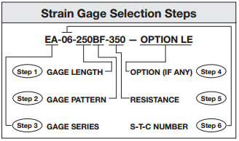

Figure Strain Gage Selection Steps

1. **Build Wheatstone Bridge:**

In order to amplify the signal given by the change in resistance of the strain gage, the Wheatstone bridge concept (Fig.15) was implemented. The concept is to make a Wheatstone bridge, consisting of 4 resistors having the same resistance and the strain gage acting as the variable resistor. Once the beam is deflected and starts to vibrate, the resistance in the strain gage will start to fluctuate between its maximum and minimum value. The change in resistance will then cause the potential difference or voltage across Rload to change. This change in voltage is then recorded using an oscilloscope. The Wheatstone bridge is constructed, using four 120 ohm resistors and the strain gage acting as the variable resistor.

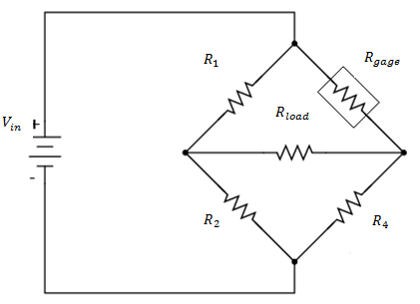

Figure Wheatstone Bridge Concept

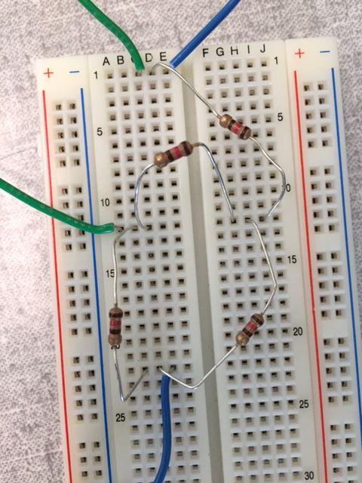

Figure Wheatstone Bridge built

1. **Connect DC power supply to circuit and oscilloscope across Rload**

After assembling the Wheatstone bridge circuit, power is supplied through a DC-Voltage power supply (Fig. 18). The oscilloscope is connected across Rload to find the potential difference across the resistor once the beam is bent and starts to vibrate.

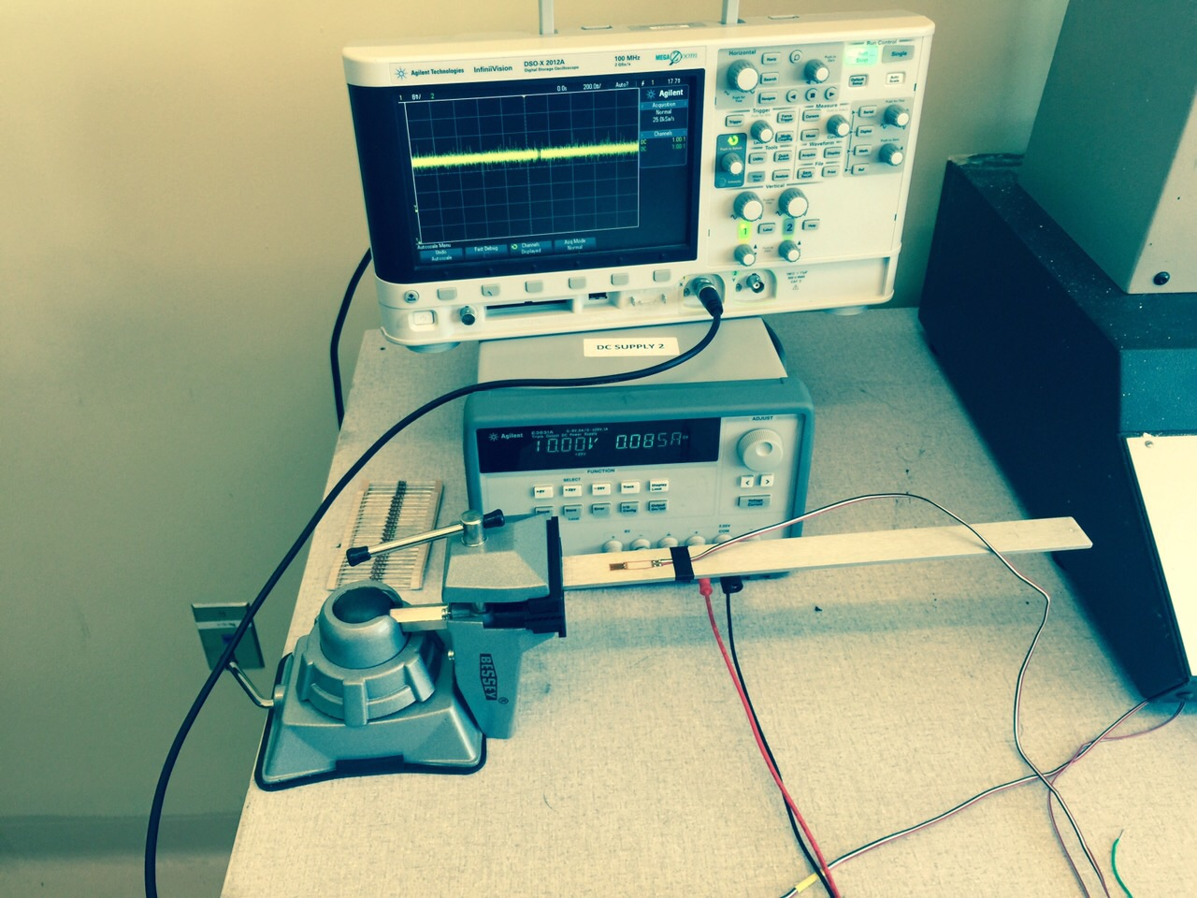

Figure Experimental Setup

At first, the results shown on the oscilloscope are not clear and a lot of noise is affecting the signal (Fig. 19).

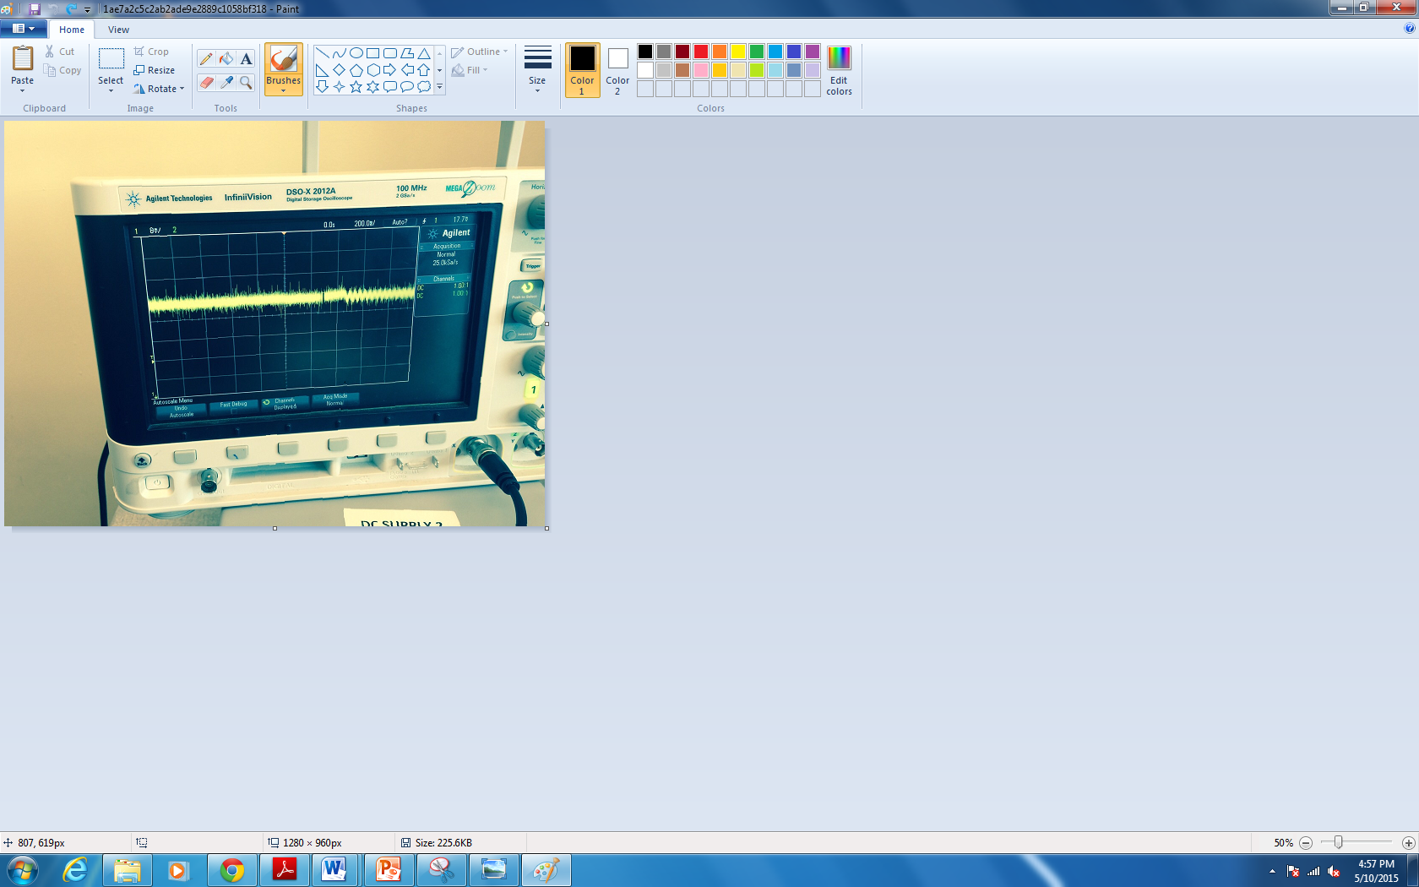

Figure Oscilliscope Display with noise effect

To reduce noise, the acquisition mode is changed to High Resolution, which in turn gives better results (Fig. 20). A USB flash drive is then inserted into the compatible port and the results shown are saved as an excel file.

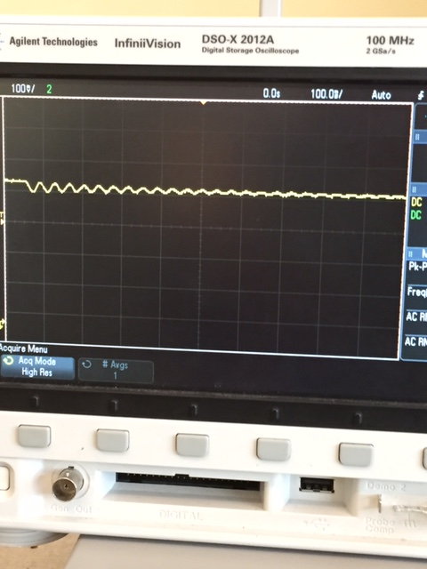

Figure High Resolution Oscilliscope Display

1. **Amplifier Setup:**

In order to easily conduct this experiment in the future, an easy to use setup was built that enables future student to easily plug in all necessary cords including the oscilloscope, DC power supply and strain gauge wires through binding posts. Post 1 in figure 21 indicates where the two wires of the strain gage will be connected. The Oscilloscope will be connected to post 2 and the DC power supply to post 3. Figure 21 shows the setup of the amplifier:

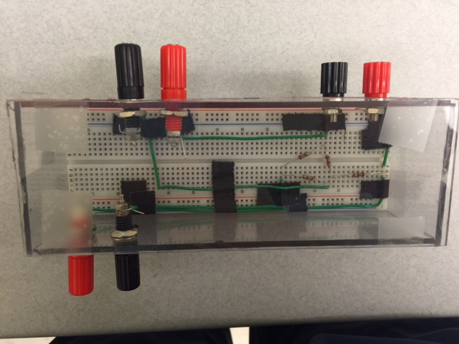

1

2

3

Figure Amplifier Setup

1. **Find the natural frequency of beam theoretically:**
$$ω_{n}={1.875}^{2}\sqrt{\frac{EI}{mL^{4}}}={1.875}^{2}\sqrt{\frac{EI}{ρAL^{4}}}=3.52\sqrt{\frac{\left(10*{10}^{6}\right)(0.0001627)}{\left(0.0002525\right)\left(0.125\right){(12)}^{4}}}=175.5\frac{rad}{sec}=27.9 Hz≈28 Hz$$

$$ρ=0.0002525\frac{lb}{in^{3}} from material specifications$$

$$A=width*thickness=1*0.125=0.125 in^2$$

2. **Numerical Analysis in CATIA:**

The same model of the beam is created on CAD model. Finite element analysis using the CATIA model can be used to compare the theoretical data with the data received from the CATIA analysis.

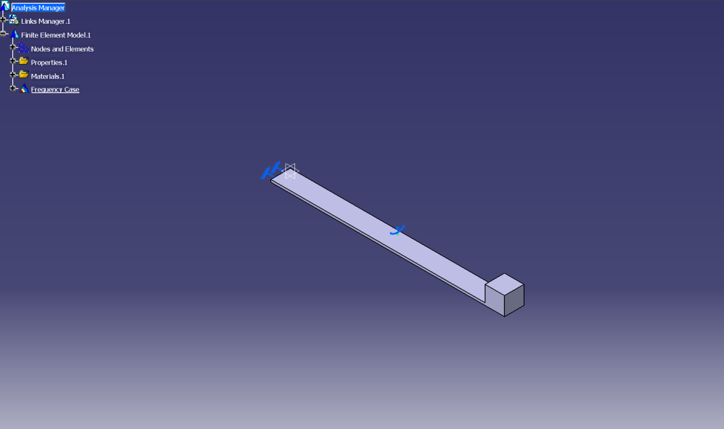

Figure Part Design of Beam on CATIA

The material is Aluminum 6061-T6 and the material properties are inputted into CATIA with same values. The aluminum beam has a Young modulus of 10000 Ksi, Poisson’s ratio of 0.33, density of 0.0975 lb/in^3 and yield strength of 45000 psi. The values are inputted into the properties windows of the part design. After selecting on aluminum for materials, the structural properties can be changed in the analysis tab (Fig 22).

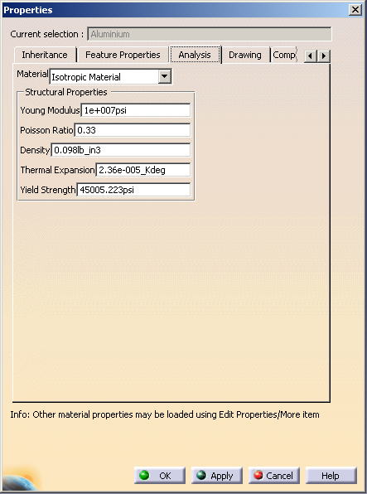

Figure Material Properties on CATIA

Generative Structural Analysis is used to analyze the beam. The value of natural frequency can be found in the Frequency Analysis since it is vibrating. After entering the finite element analysis, green and blue icon will appear in the middle of the screen and these represents the size and sag of the mesh. The size and sag of the mesh and the element type can be changed in the OCTREE Tetrahedron Mesh windows. Parabolic element type is usually preferred since it provides accurate results (Fig 23).

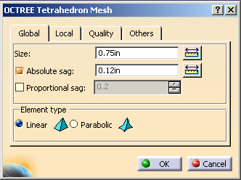

Figure Mesh Configurations

In order to determine the most effective amount of size and sag for finite element analysis, conversion line is necessary. The smaller the size and sag of the elements will provide accurate results. However, if the size and sag are too small, the computation will take longer to complete. As the mesh gets smaller in size, the value will reach a steady state, which is the conversion line. Conversion line is necessary in order to find the most efficient size and sag relative to the computation time of the analysis.

Figure Mesh Convergence Study

The height of the mass is the only dimension that can be changed. Changing other dimensions would change the structure of the cantilever beam. Mass is equal to the volume times the density of the mass. Height is subtracted by the height of the beam since this equation involves the height of the beam as well.

$$v=\frac{m}{ρ}→Lbh=\frac{m}{ρ}→h=\frac{m}{Lbρ}=\frac{(0.03426)}{(12)(1)(0.00303)}=0.9422-0.125=0.8172 in$$

m: mass (0.03426 slug)

$ρ$: Density (0.00303 $\frac{slug}{{in}^{3}})$

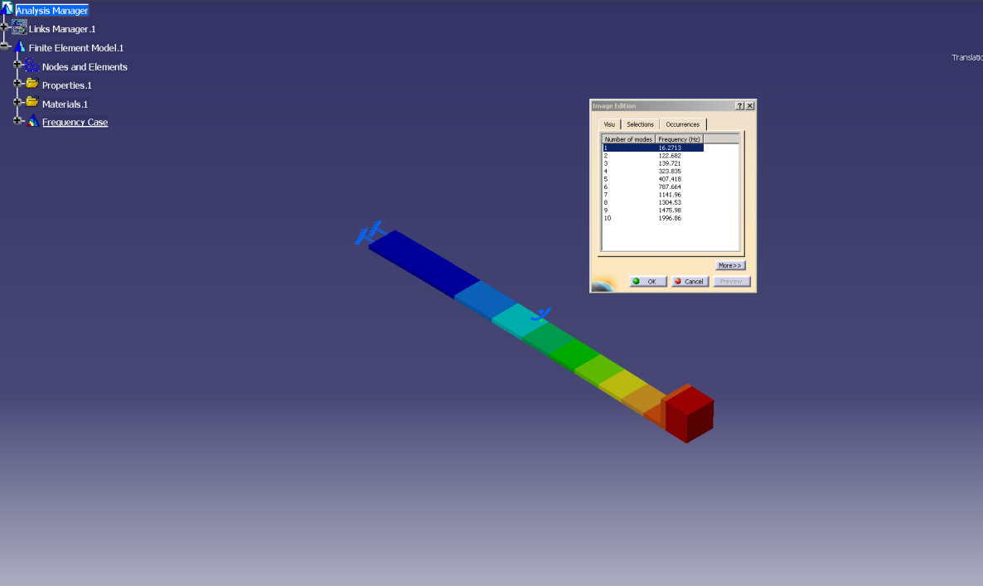

Figure Displacement Representation on CATIA for mass at 12”

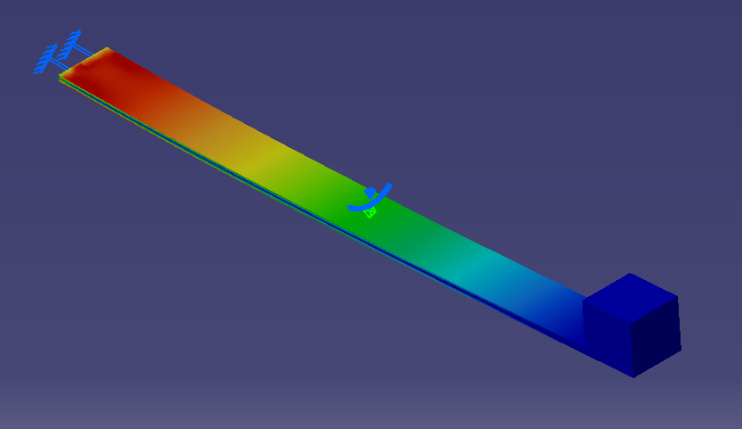

Figure Stress analysis of beam with mass at 12”

By utilizing finite element analysis through CATIA, the values of natural frequency can be found. The displacement and the Von Mises Stress values of the beam are categorized into colors. The blue represents small changes and the red represents significant amount of change.

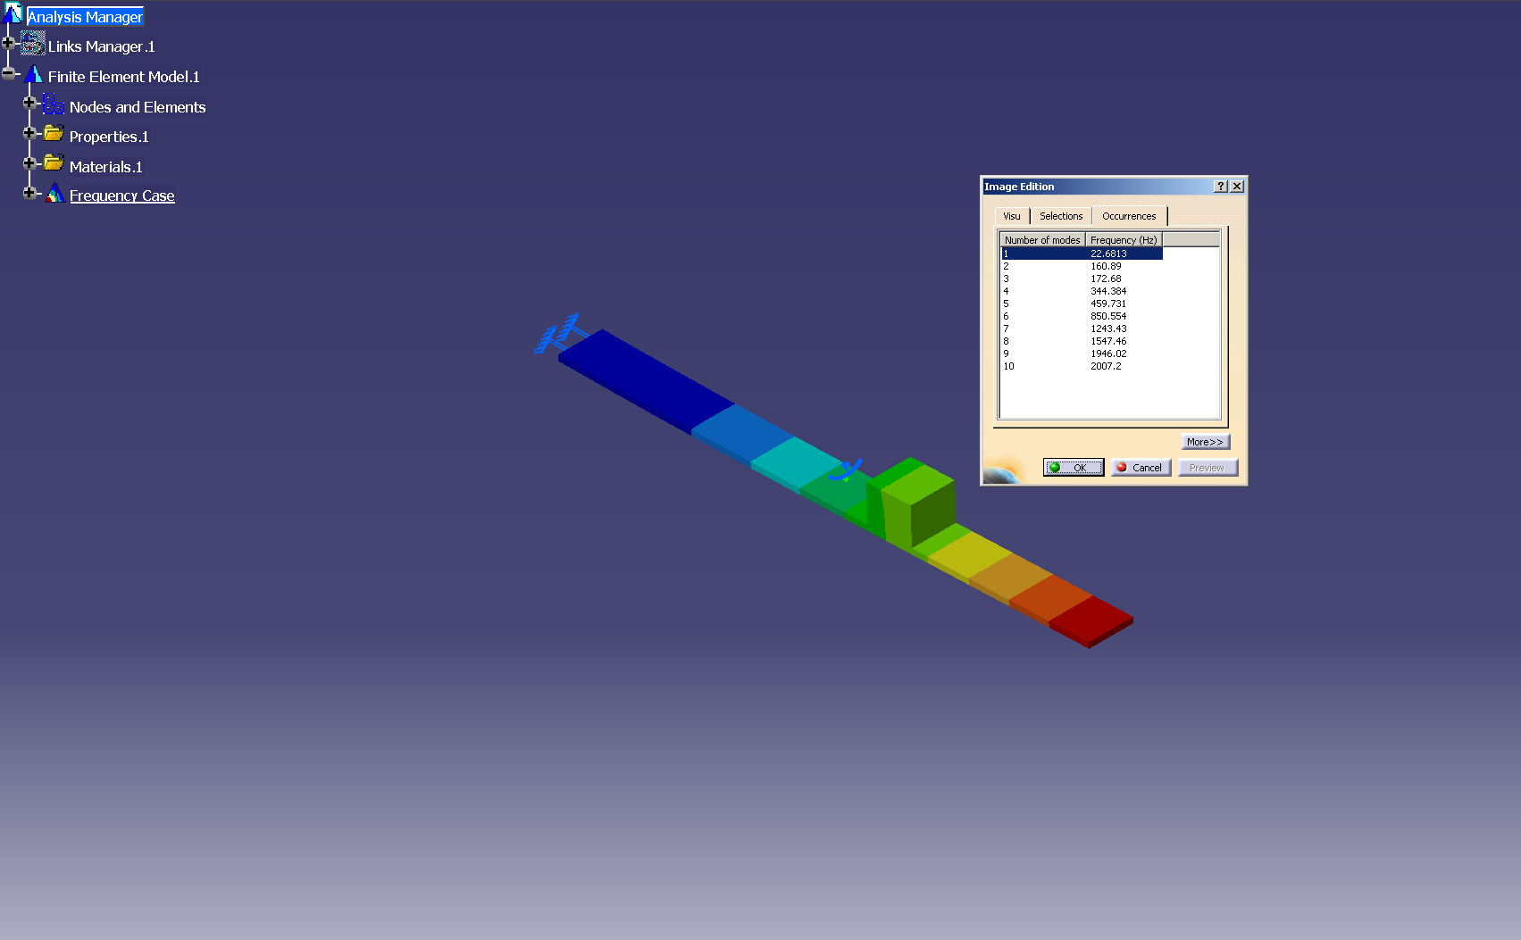

Figure Displacement Representation on CATIA for mass at 8”

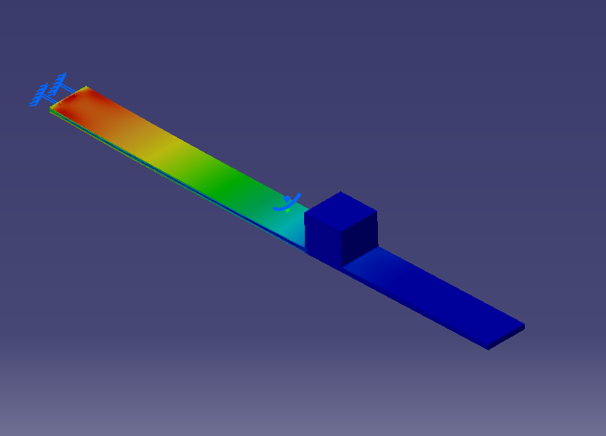

Figure Stress analysis of beam with mass at 8”

For displacement, the mass at one end is the most displaced part of the beam. For Von Mises stress, the root of the beam is experiencing highest value of stress. This same method is utilized in every location of the beam in 2-inch increments.

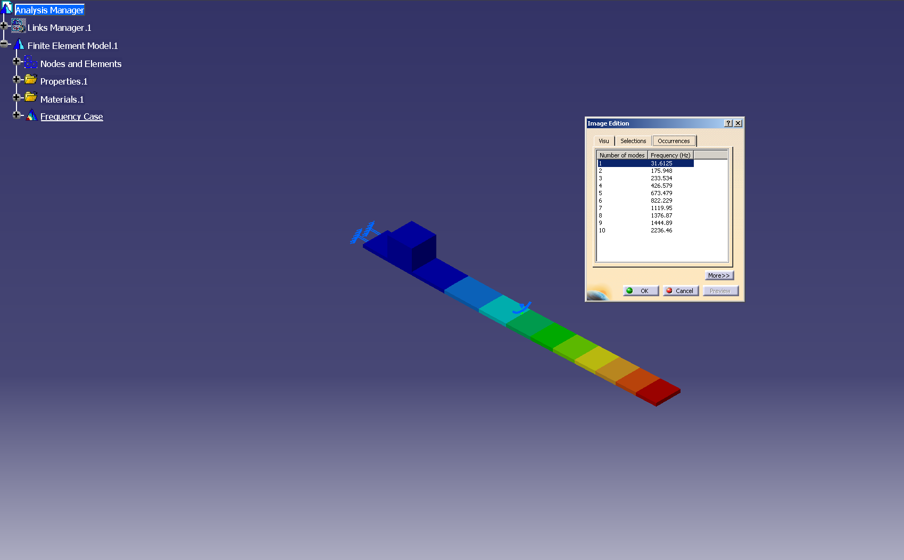

Figure Displacement Representation on CATIA for mass at 2”

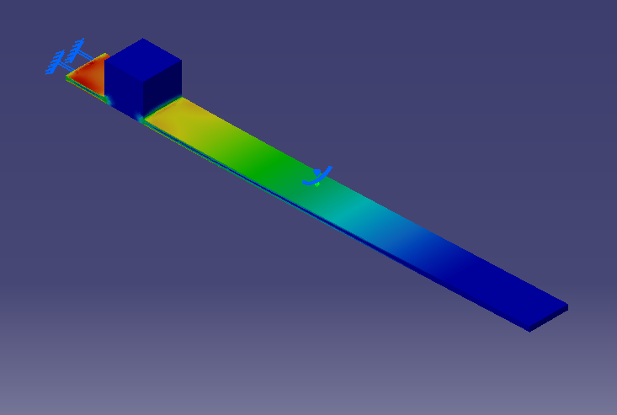

Figure Stress analysis of beam with mass at 2”

1. **Experimental Results and Analysis:**

The strain can be measured on the oscilloscope with the use of breadboard, voltage source, resistors and the strain gauge attached on the beam. The bridge setup was used to receive a change in resistance of the beam. The resistances of 120ohms were needed to match the resistance of the strain gauge. Since the difference was too small, amplifiers were used. However, due to the noise created from other factors, accurate data could not be reached. The oscilloscope had a high-resolution option where the data was successfully reached. The logarithmic decrement or how fast damping occurs can be calculated. This whole process can be used to see where the different mass locations will cause different values of logarithmic decrement.

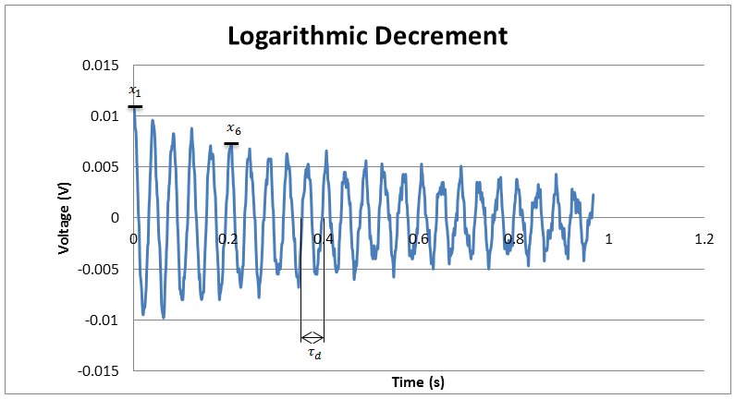

Figure Oscillisocsope Results Exported to Excel Spreadsheet

To find the damping constant and natural frequency of the beam the first step is to extract the information given by the oscilloscope with the help of an excel sheet as seen in Fig.31. Table one below shows all initial values (amplitude, number of cycles, and damped period of vibration) obtained from the plot.

Table 1

Initial Values Obtained form the Plot at different mass locations

|  |  |  |  |  |
| --- | --- | --- | --- | --- |
| Location | x1 | xn+1 | n | Td |
| No mass | 0.0138 | 0.0078 | 11 | 0.038545 |
| 4 | 0.0143 | 0.0072 | 11 | 0.042708 |
| 6 | 0.0141 | 0.0083 | 11 | 0.0520836 |
| 8 | 0.0148 | 0.0085 | 12 | 0.060417 |
| 10 | 0.0186 | 0.0141 | 9 | 0.079167 |
| 12 | 0.0098 | 0.0086 | 5 | 0.103122 |

The next step is to use the data collected to find the Logarithmic decrement and damping ration using the formulas detailed in the Mathematical formulations section on page 11. Table 12 shows the values of the logarithmic decrement and damping ratio at different mass locations.

Table2

Logarithmic Decrement and Damping Ratio at different mass locations

|  |  |  |
| --- | --- | --- |
| Location | Log Decrement (δ) | Damping Ratio (ζ) |
| No mass | 0.051867714 | 0.008254724 |
| 4 | 0.062379865 | 0.009927577 |
| 6 | 0.04817448 | 0.007666983 |
| 8 | 0.046213418 | 0.007354897 |
| 10 | 0.030776309 | 0.004898144 |
| 12 | 0.026124036 | 0.004157735 |

The final step is to calculate the damped natural frequency, natural frequency, critical damping and damping coefficients from the obtained data in tables 1 and 2. Table 3 below shows the results calculated using the mathematical formulations on page 11.

Table 3

Values of Damped Natural Frequency, Natural Frequency, Critical Damping and Damping Coefficient.

|  |  |  |  |  |
| --- | --- | --- | --- | --- |
| Location | Wd | Wn (Hz) | Cc | c |
| No mass | 163.0090803 | 25.94458612 | 0.1796 | 0.001482548 |
| 4 | 147.1196263 | 23.41597083 | 0.1796 | 0.001782993 |
| 6 | 120.6365343 | 19.20046603 | 0.1796 | 0.00137699 |
| 8 | 103.9969711 | 16.55208051 | 0.1796 | 0.001320939 |
| 10 | 79.36621319 | 12.63167729 | 0.1796 | 0.000879707 |
| 12 | 60.92962704 | 9.697335617 | 0.1796 | 0.000746729 |

From Figure 32, the time between two dissipating amplitudes are increasing, as the weights are placed farther away from the clamp. The decrease in damping can be visibly seen from the figure above.

Figure Plots exported from Oscilloscope

Table 4

FEA Results for Natural Frequency at Different Mass Locations

|  |  |  |
| --- | --- | --- |
| Mass Location (in) | $W_{n}$ (Hz) |  |
| No Mass | 28 |  |
| 0 | 33 |  |
| 2 | 31.61 |  |
| 4 | 29.14 |  |
| 6 | 26.14 |  |
| 8 | 22.68 |  |
| 10 | 19.28 |  |
| 12 | 16.27 |  |

The above table summarizes the results for natural frequency at different locations through finite element analysis. The values given in this table are the true values since it is done by FEA software.

Figure Plot of Natural Frequency vs. Mass Location

By creating a polynomial trend line of the graph in Figure 13, the natural frequency as a function of mass location is created:

$${(ω_{n})}_{(x)}=0.0072x^{3}-0.1694x^{2}-0.3915x+33$$

With this function, the value of natural frequency can be found no matter where the mass is placed on the cantilever beam. The experimental values have the same relationship as the FEA values. The chart shows that as the mass is farther away from the cantilever beam, the value of natural frequency decreases.

Figure Plot of Damping Coeffecient vs. Mass Location

The polynomial trend line is created in Figure 14 as well. The damping ratio as a function of mass location is:

$$ζ_{(x)}=(6*{10}^{-5})x^{2}-0.0017x+0.0156$$

The value of damping ratio can be found no matter where the mass is placed on the cantilever beam. The relationship of damping ratio is similar to the natural frequency. As seen on the plot above (fig.26), when the mass is placed farther from the fixed end the damping ratio decreases.

Table 5

Percentage Error of Natural Frequency

|  |  |  |  |
| --- | --- | --- | --- |
| Numerical | Theoretical | Experimental | %Error |
| 28Hz | 28Hz | 26Hz | 7.14% |

1. **Discussion of Results:**

Comparing FEA and experimental results, one can see that mass location does have an effect on the natural frequency of an object. After creating the beam on CATIA the natural frequency was found with no mass and a mass at 2 in intervals away from the fixed end. Referring to table 2, the natural frequency decreased from 33 to 16.2 Hz when the mass was moved from the fixed end up to the free end. After obtaining the change in resistance in the strain gage experimentally, the data points were plotted using excel spreadsheets (Refer to Fig 11). From the plots created the logarithmic decrement was found using the change in amplitude after a certain number of cycles. Damping Ratio, Damped natural Frequency and Natural frequency were then found using the formulations derived (Refer to Technical Approach). Like FEA, experimental results showed the same effect of mass location on natural frequency. Due to the mounting of the strain gage on the beam the natural frequency was not found at the fixed end and 2 inches away from the fixed end. There proved to be a difference between the results found experimentally and using FEA. The % error between the two methods is around 7%. This large error is mainly caused by the configuration of the mass used in the experimental results. This experiment deals with both viscous and material damping. The air acts as viscous damping and the material of the beam and magnets acts as the material damping.

1. **Team Responsibilities:**

* Mohammed Ayoub: Main responsibilities include experimental setup and retrieving experimental data. Worked closely with Dr. Flavio Cabrera to build an amplifier to enhance strain gage signal. Also built amplifier case for easy-to-conduct experiments in the future. Contributed in writing the final paper
* Sanghoon Han: Main responsibilities include numerical and analytical analysis. Designed all CATIA parts and conducted most CATIA analysis on beam. Contributed in writing final paper and lab manual.
* Cannon Patel: Main responsibility included research for ordering of all supplies including aluminum beams, clamp fixture, breadboards and resistors. Worked closely with Dr. Yougahswar Budhoo to mount the strain gage on beam and ensure its functionality. Responsible for weekly reports and progress status. Moreover, contributed in writing final paper.

1. **Project Management:**

Table 6

Components and Equipment Used

|  |  |  |
| --- | --- | --- |
| Components | Description | Quantity |
| Aluminum Beam | Aluminum 6061-T6 | 1 |
| Strain Gauge | CEA-13-062UW-350 | 1 |
| Clamp Fixture | 2-3/4 in. Swiveling Vacuum Base Vise | 1 |
| Resistors | 120Ω | 4 |
| Breadboard | BB830 Solderless Plug-in | 1 |
| Oscilloscope | Agilent Technologies DSO-X 2012A | 1 |
| Power Supply | Agilent E3631A DC | 1 |
| Bonding Material for Strain Gauge | M-Bond 200 | 1 |
| Magnets | Master Magnets Inc. | 4 |

1. **Conclusion**

In conclusion, the natural frequency and damping ratio of the beam was affected by the mass location. The farther the mass is away from the fixed end the lower the natural frequency and damping ratio. FEA and experimental approach both showed the same effect of mass location on Damping and Natural frequency. At the start of the experiment, only viscous damping was considered, but with the differences in the results shows that material damping needs to be considered as well. Both natural frequency and damping ratio as a function of mass location is found through the experiment. Anyone can utilize this function in order to find the exact value of damping ratio and natural frequency for this experiment.

1. **Acknowledgment**

Special thanks to Dr. Yougashwar Budhoo for all his support and guidance throughout this project and high appreciation and thanks to Dr. Flavio Cabrera for his help.

1. **References:**

[1]Ferdinancd P, Beer, E. Russell Johnston, Jr, John T. DeWolf, David F. Mazurek “Mechanics of Materials” 6th ed, Print, March 11, 2015.

[2] Budynas, Nisbett. “Shigley's Mechanical Engineering Design” 8th ed. McGraw-Hill Primis. Print March 8, 2015.

[3] Singiresu S. Rao, “Mechanical Vibrations” 5th ed. Prentice Hall. Print, March 15, 2015.

[4] "Free Vibration of a Cantilever Beam." SakShat Virtual Labs. NME Initiative of MHRD, 1 Jan. 2015. Web. 8 Mar. 2015. <http://iitg.vlab.co.in/?sub=62&brch=175&sim=1080&cnt=1>

[5] Whitney, Scott. "Vibrations of Cantilever Beams: Deflection, Frequency, and Research Uses." Vibrations of Cantilever Beams: Deflection, Frequency, and Research Uses. 23 Apr. 1999. Web. 12 Mar. 2015. http://emweb.unl.edu/Mechanics-Pages/Scott-Whitney/325hweb/Beams.htm

[6] "Strain Gage Selection: Criteria, Procedures, Recommendations." Micro-Measurements. Vishaypg, 14 Aug. 2014. Web. 8 Mar. 2015. <http://www.vishaypg.com

1. **List of Images:**

|  |  |
| --- | --- |
| Figure | Description |
| 1 | Vibrating Structures |
| 2 | Using Logarithmic Method to Find Damping Ratio |
| 3 | Three Different Cases of Damping |
| 4 | Tacoma Narrows Bridge Collapsing |
| 5 | Representation of one cycle |
| 6 | Represenattion of amplitude and period |
| 7 | Spring Damper System |
| 8 | Stress Strain Curve |
| 9 | Strain Gage |
| 10 | Loading on Cantilever Beam |
| 11 | Cross-Sectional Dimensions of a Rectangular Beam |
| 12 | Maximum Displacement Visualization |
| 13 | Damping Effect |
| 14 | Flow Chart |
| 15 | Strain Gage Selection Steps |
| 16 | Wheatstone Bridge Concept |
| 17 | Wheatstone Bridge built |
| 18 | Experimental Setup |
| 19 | Oscilliscope Display with noise effect |
| 20 | High Resolution Oscilliscope Display |
| 21 | Amplifier Setup |
| 22 | Part Design of Beam on CATIA |
| 23 | Material Properties on CATIA |
| 24 | Mesh Configurations |
| 25 | Mesh Convergence Study |
| 26 | Displacement Representation on CATIA for mass at 12” |
| 27 | Stress analysis of beam with mass at 12” |
| 28 | Displacement Representation on CATIA for mass at 8’ |
| 29 | Stress analysis of beam with mass at 8” |
| 30 | Displacement Representation on CATIA for mass at 2” |
| 31 | Stress analysis of beam with mass at 2” |
| 32 | Oscillisocsope Results Exported to Excel Spreadsheet |
| 33 | Plots exported from Oscilloscope |
| 34 | Plot of Natural Frequency vs. Mass Location |
| 35 | Plot of Damping Coeffecient vs. Mass Location |

1. **Appendix A:**

**Oscilloscope Data:**

**CATIA Results:**



Displacement Representation on CATIA for mass at 12”



Stress analysis of beam with mass at 12”



Displacement Representation on CATIA for mass at 8”



Stress analysis of beam with mass at 8”



Displacement Representation on CATIA for mass at 2”



Stress analysis of beam with mass at 2”

|  |  |
| --- | --- |
| Mass location | Wn |
| 0 | 33 |
| 2 | 31.61 |
| 4 | 29.14 |
| 6 | 26.14 |
| 8 | 22.68 |
| 10 | 19.28 |
| 12 | 16.27 |

Figure 36 Mesh Convergence Study

**Tables of Experimental Results:**

Initial Values Obtained form the Plot at different mass locations

|  |  |  |  |  |
| --- | --- | --- | --- | --- |
| Location | x1 | xn+1 | n | Td |
| No mass | 0.0138 | 0.0078 | 11 | 0.038545 |
| 4 | 0.0143 | 0.0072 | 11 | 0.042708 |
| 6 | 0.0141 | 0.0083 | 11 | 0.0520836 |
| 8 | 0.0148 | 0.0085 | 12 | 0.060417 |
| 10 | 0.0186 | 0.0141 | 9 | 0.079167 |
| 12 | 0.0098 | 0.0086 | 5 | 0.103122 |

Logarithmic Decrement and Damping Ratio at different mass locations

|  |  |  |
| --- | --- | --- |
| Location | Log Decrement (δ) | Damping Ratio (ζ) |
| No mass | 0.051867714 | 0.008254724 |
| 4 | 0.062379865 | 0.009927577 |
| 6 | 0.04817448 | 0.007666983 |
| 8 | 0.046213418 | 0.007354897 |
| 10 | 0.030776309 | 0.004898144 |
| 12 | 0.026124036 | 0.004157735 |

Values of Damped Natural Frequency, Natural Frequency, Critical Damping and Damping Coefficient.

|  |  |  |  |  |
| --- | --- | --- | --- | --- |
| Location | Wd | Wn (Hz) | Cc | c |
| No mass | 163.0090803 | 25.94458612 | 0.1796 | 0.001482548 |
| 4 | 147.1196263 | 23.41597083 | 0.1796 | 0.001782993 |
| 6 | 120.6365343 | 19.20046603 | 0.1796 | 0.00137699 |
| 8 | 103.9969711 | 16.55208051 | 0.1796 | 0.001320939 |
| 10 | 79.36621319 | 12.63167729 | 0.1796 | 0.000879707 |
| 12 | 60.92962704 | 9.697335617 | 0.1796 | 0.000746729 |

**Plots of Experimental Results:**

Plot of Natural Frequency vs. Mass Location

Plot of Damping Coeffecient vs. Mass Location

**Percentage Error Calculations:**

Percentage Error of Natural Frequency

|  |  |  |  |
| --- | --- | --- | --- |
| Numerical | Theoretical | Experimental | %Error |
| 28Hz | 28Hz | 26Hz | 7.14% |

**Experimental Setup:**



Amplifier Setup



Experimental Setup